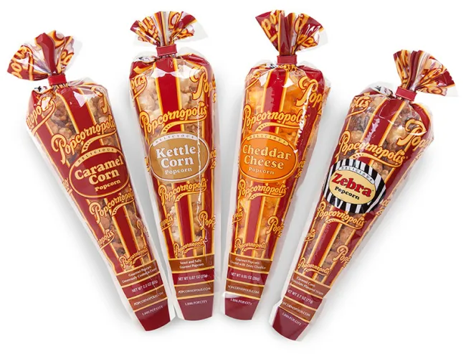

**Los Angeles LOMOD Corporation**

**POPCORN FUNDRAISER!**

**Aug. 16th thru 30th**

**Go to the Website below:**

**“25% of purchase sales will go to” School on Wheels”**

THANK YOU!

[**https://fundraising.popcornopolis.com/pages/los-angeles-lomod-corporation**](https://fundraising.popcornopolis.com/pages/los-angeles-lomod-corporation)

